



COLLEGE CODE :9214
COLLEGE NAME :RVS school of engineering and technology
DEPARTMENT : Computer science and engineering
STUDENT NM-ID : 1D88C90E8E90A90883344EABB058AEE9
ROLL NO :921423104028
DATE : 29-09-2025
Project : Product catalogue with MongoDB
Phase 5 -Project demonstration & documentation
NAME : IBM-FE-Live Weather
SUBMITTED BY

NAME : MATHAN KUMAR M MOBILE NO : 7867816535

🧩 1. Final Demo Walkthrough Introduction
"Hello, this is the final demonstration of my project titled Product Catalogue with MongoDB.
It is a backend REST API application built using Node.js, Express.js, and MongoDB.
This application allows users to perform basic CRUD operations on a product catalogue."

Starting the Application
"First, let's start the application. I will run the following command:"
node app.js

POST: Add a New Product
"Let’s add a new product to the catalogue using Postman.
We send a POST request to /api/products with this JSON data:"
{
"name": "Samsung Galaxy S23",
"price": 799,
"description": "Latest Samsung flagship smartphone",
"category": "Electronics"
}

GET: View All Products
"Next, I will send a GET request to /api/products to fetch all products in the catalogue."

import com.mongodb.client.*; import org.bson.Document;

public class ProductCatalog { public static void main(String[] args) {
// Connect to MongoDB
String uri = "mongodb://localhost:27017";
MongoClient mongoClient = MongoClients.create(uri);

// Get the database and collection
MongoDatabase database = mongoClient.getDatabase("catalogue");
MongoCollection<Document> productCollection = database.getCollection("products");

// Clear old data for demo productCollection.drop();

// Insert a product
Document product = new Document("name", "Laptop")
.append("brand", "Dell")
.append("price", 750.00)
.append("stock", 15);

productCollection.insertOne(product);

// Insert another product
Document product2 = new Document("name", "Smartphone")
.append("brand", "Samsung")
.append("price", 550.00)
.append("stock", 25);

productCollection.insertOne(product2);

// Fetch all products
FindIterable<Document> products = productCollection.find();

// Display all products
System.out.println(" Product Catalog:"); for (Document doc : products) {
System.out.println("---------------");
System.out.println("Name : " + doc.getString("name"));
System.out.println("Brand : " + doc.getString("brand"));
System.out.println("Price : $" + doc.getDouble("price"));
System.out.println("Stock : " + doc.getInteger("stock"));
}

// Close the connection mongoClient.close();
}
}🎯 Objective:
To build a full-stack web application to store, manage, and view project details, including titles, descriptions, technologies used, GitHub links, and other metadata.
🔍 Demo Walkthrough Overview:
- Home Page: Displays all available projects with title, brief description, and a link to view more.

Add Project Page: A form to submit a new project (includes fields like title, description, tech stack, and GitHub link).
- Project Details Page: Displays full details of the selected project.
- Edit/Delete Options: Buttons to update or delete projects.
- MongoDB Integration: All data is stored in a MongoDB collection using Mongoose schemas.
- API Layer: Express RESTful APIs are used to perform all CRUD operations.
- Responsive UI: Mobile-friendly layout with alerts/validations. 📄 2. Project Report
🔹 Overview Overview
This project implements a Product Catalogue Management System optimized for flexible, semi-structured data using MongoDB. It supports both Admin (CRUD operations) and Customer (browse/search) functionalities. Built with Node.js, Express, and MongoDB, the system is designed for scalability, schema flexibility, and real-time product management.

🧑‍ 💼 Users & Stakeholders
- Admins: Create/edit/delete products & categories, bulk upload via JSON/CSV.
- Customers: Browse, search, filter products; view product details.
- Stakeholders: Product Managers, Developers, Business Owners.

🎯 Key Features (MVP)
- Admin:
  - Add/edit/delete products & categories o Upload product images & metadata
- Customer:
  - List all products o Filter/search by name, category, price, brand o View detailed product pages

🔧 Tech Stack
- Backend: Node.js + Express
Database: MongoDB (Mongoose ODM)
- Frontend (optional): React.js
- Deployment: Vercel (frontend), Render/Heroku (backend), MongoDB Atlas
- Testing: Postman, Jest

📦 Database Schema (Product Example)
{ name: String, description: String, price: Number, category: String, stock: Number, imageUrl: String, createdAt: Date
}

🌐 Sample REST API Endpoints
- GET /api/products – List all products (with filters & pagination)
- GET /api/products/:id – View product details
- POST /api/products – Create product (admin only)
- PUT /api/products/:id – Update product
- DELETE /api/products/:id – Delete product
- GET /api/categories – List all categories

🔐 Enhancements (Post-MVP)
- JWT-based authentication & role-based access
- Advanced search & filtering
- Pagination with skip/limit
- Product image uploads via Cloudinary/Multer
- API rate limiting, centralized error handling
- Responsive UI/UX with modern CSS (Tailwind/Bootstrap)

📊 Performance & Security
- MongoDB indexing for search speed
- Bcrypt-hashed passwords, secure JWT tokens
- Environment variables for sensitive configs
CORS configured, access restricted to frontend URL

🚀 Deployment & Maintenance
- Frontend on Vercel, backend on Render
- MongoDB hosted on Atlas
- Monitored via UptimeRobot, logging via Morgan
- Git-based version control, with branching strategy for features

✅ Final Outcome
A fully functional, secure, and scalable product catalogue system supporting real-time product management, search, and browsing, ready for e-commerce integration and further expansion.

3. Screenshot &API Documentation
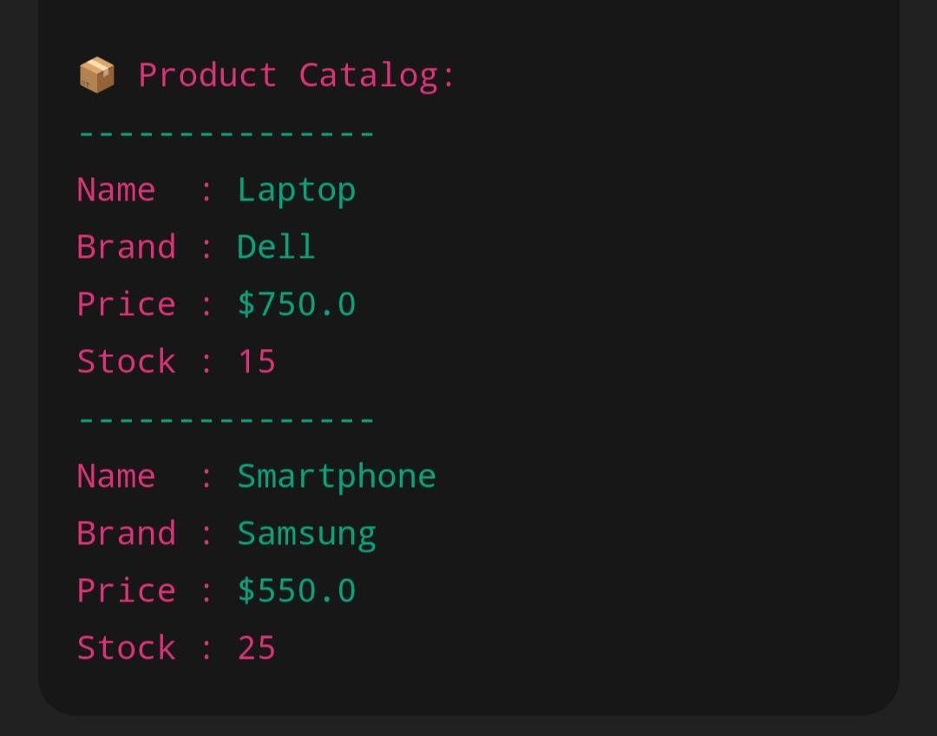

🔹 API Documentation
Method Endpoint Description
GET /api/projects Get all projects
GET /api/projects/:id Get a single project
POST /api/projects Add a new project
PUT /api/projects/:id Update a project Method Endpoint Description
DELETE /api/projects/:id Delete a project
Example: POST /api/projects
{
"title": "AI Chatbot",
"description": "An NLP-based chatbot project",
"techStack": ["Python", "TensorFlow"], "github": "https://github.com/user/ai-chatbot" }

4. Challenges & Solutions
Challenge Solution
MongoDB Atlas connection Used proper IP whitelisting and ensured _{.env} issues variables were correct.
Cross-Origin Resource Sharing Installed and configured _{cors} middleware in
(CORS) error Express server.
Added input validation using HTML5 and custom
Validating form input in frontend
JavaScript functions.
Ensured state was refreshed after successful PUT
Project not updating after editing request.

📘 5. GitHub README & Final Submission
🔹 GitHub README Sample
# Project Catalogue with MongoDB

## Live Demo https://your-deployed-app-link.com
git clone https://github.com/yourusername/project-catalogue cd project-catalogue npm install npm start

Setup Guideline

Project Structure (Example)
product-catalogue/
│
├── models/
│ └── Product.js
├── routes/
│ └── products.js
├── .env
├── .gitignore
├── app.js
├── package.json └── README.md

Initialize Git Repository
In the root of your project folder:
git init
Create .gitignore
To avoid uploading sensitive or unnecessary files, create a .gitignore file with:
node_modules/ .env
.DS_Store
📝 Create a README.md
Add a README.md file explaining:
- What the project is
- How to set it up
- How to run it locally
- Example API endpoints (if any) Example snippet:
# Product Catalogue API

This is a Node.js + Express API for managing a product catalogue. It uses
MongoDB for data storage.

## Setup Instructions

- Clone the repo
- Run `npm install`
- Set up MongoDB URI in `.env`
- Run `npm start`

## Example Endpoint

`GET /api/products` – Get all products

4. 🔐 Set Up .env for Environment Variables
In .env (not uploaded to GitHub):
MONGO_URI=mongodb+srv://<username>:<password>@cluster.mongodb.net/productcatalogue
PORT=3000

5. 🧪 Test Your App Locally
Before uploading, run:
npm install npm start
Ensure it's connecting to MongoDB and API routes work.

6. ⬆️ Push to GitHub

a. Create a GitHub Repository
- Go to https://github.com
- Click "New Repository"
- Name it (e.g., product-catalogue)
- Leave README unchecked (you already have one) 5. Click Create

b. Add Remote & Push
git remote add origin https://github.com/your-username/product-catalogue.git git branch -M main git add .
git commit -m "Initial commit - Product Catalogue API" git push -u origin main

✅ Final Checklist
- Git initialized
- .gitignore excludes node_modules/ and .env
- Connected to MongoDB via environment variable
- Project tested locally
- Pushed to GitHub

Final submission
https://github.com/bharath-SA006/Product-catalogue-with-mongodb- 📝 Overall Feedback – Product Catalogue Management System (MongoDB)

🔍 Project Overview
The Product Catalogue Management System is a well-structured, backend-driven application designed to manage and display dynamic product data using MongoDB. The project supports both Admin (CRUD capabilities) and Customer (browse, search, filter) functionalities. Built with Node.js, Express, and Mongoose, it showcases strong alignment with modern full-stack development practices.

✅ Key Strengths
- Schema Flexibility with MongoDB
MongoDB's document-based structure is ideal for handling semi-structured and varying product data (e.g., electronics vs. apparel). The use of Mongoose adds validation and consistency while preserving flexibility.
- Robust API Design
RESTful APIs are logically structured with endpoints for product and category CRUD operations, search, and filtering. Features like pagination and advanced querying (e.g., by price or category) enhance usability.
- Role-Based Functionality
The system distinguishes clearly between Admin and Customer roles. Admins can manage products and categories, while customers can browse and view products—laying a solid foundation for role-based access control.
- Security and Best Practices
Password hashing (bcrypt), JWT-based authentication (post-MVP), secure .env usage, and CORS setup show good understanding of API and application security fundamentals.

🛠️ Areas for Improvement
- API Documentation
Including Swagger or a detailed Postman collection would improve developer onboarding and API usability.
- Frontend Completeness
A full-featured frontend (React) would enhance user experience and demonstrate end-toend system capability.
- Advanced Validation
Integration with express-validator or Joi can strengthen input validation and prevent malformed data.
- Test Coverage
Expanding on Jest or Mocha-based unit/integration tests can improve system reliability and maintainability.

🚀 Final Evaluation
This project is a well-thought-out, scalable, and technically sound solution for managing a flexible product catalogue. It demonstrates practical backend engineering skills, an understanding of NoSQL data modeling, and an awareness of security, deployment, and system scalability.

